1. Write a program to create the login form with necessary validations like length of
username and password, empty text fields, count of unsuccessful login attempts.
Display the login successful/Unsuccessful toastmessage.

activity_main.xml
<?xml version="1.0" encoding="utf-8"?>
<RelativeLayout xmlns:android="http://schemas.android.com/apk/res/android"
xmlns:app="http://schemas.android.com/apk/res-auto"
xmlns:tools="http://schemas.android.com/tools"
android:layout_width="match_parent"
android:layout_height="match_parent"
tools:context="com.onlinetutorialspoint.official.simplelogin.MainActivity">

<LinearLayout
android:layout_width="match_parent"
android:layout_height="wrap_content"
android:orientation="vertical"
android:layout_marginLeft="16dp"
android:layout_marginRight="16dp"

android:layout_centerInParent="true">

<EditText
android:layout_width="match_parent"
android:layout_height="wrap_content"
android:hint="UserName"
android:id="@+id/username"/>
<EditText
android:layout_width="match_parent"
android:layout_height="wrap_content"
android:hint="password"
android:id="@+id/password"
android:inputType="textPassword"
/>

<Button
android:layout_width="match_parent"
android:layout_height="wrap_content"
android:text="Login"
android:background="#3f76ff"
android:textColor="#fff"
android:id="@+id/login"/>

</LinearLayout>

</RelativeLayout>

MainActivity.java
package com.onlinetutorialspoint.official.simplelogin;

import android.support.v7.app.AppCompatActivity;
import android.os.Bundle;
import android.view.View;
import android.widget.Button;
import android.widget.EditText;
import android.widget.Toast;

import java.util.Objects;

public class MainActivity extends AppCompatActivity {
EditText username,password;
Button login;
@Override
protected void onCreate(Bundle savedInstanceState) {
super.onCreate(savedInstanceState);
setContentView(R.layout.activity_main);
username=findViewById(R.id.username);
password=findViewById(R.id.password);
login=findViewById(R.id.login);
login.setOnClickListener(new View.OnClickListener() {
@Override
public void onClick(View view) {
if(Objects.equals(username.getText().toString(), "admin")&&Objects.equals(password.getText().toString(),"admin"))
{
Toast.makeText(MainActivity.this,"You have Authenticated Successfully",Toast.LENGTH_LONG).show();

}else
{
Toast.makeText(MainActivity.this,"Authentication Failed",Toast.LENGTH_LONG).show();
}

}
});

}
}
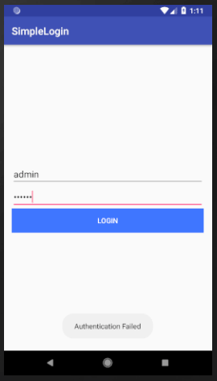
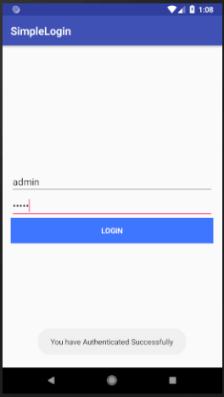
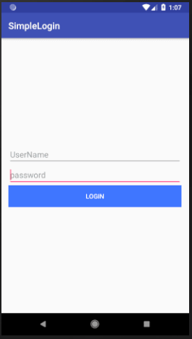
output:-

